**Validation And Troubleshooting**

There are three main parts, listed as follows:

1. Image Request or Adobe Beacon
2. DTM Rule
3. Testing For Rules
4. **Image Request or Adobe Beacon :**

Visit the web page, inspect the element and click on network tab.

Check for Adobe analytics by searching /ss or b/ss in filter.

Check whether the element is tagged or not. If not tagged, enter the element tag and track id in SRS.

Check for certain global variables, evars, props, and events which are mentioned in SRS.

1. **DTM Rule :**

DTM rule are again divided into three parts, they are:

1. Event based
2. Page load rules
3. Direct rule

**Event based rules** are made for events, where the majority of interaction on site take place. Rules are executed when the visitors interact with on-page elements.

**Event based rules** are created in the interface as follows:

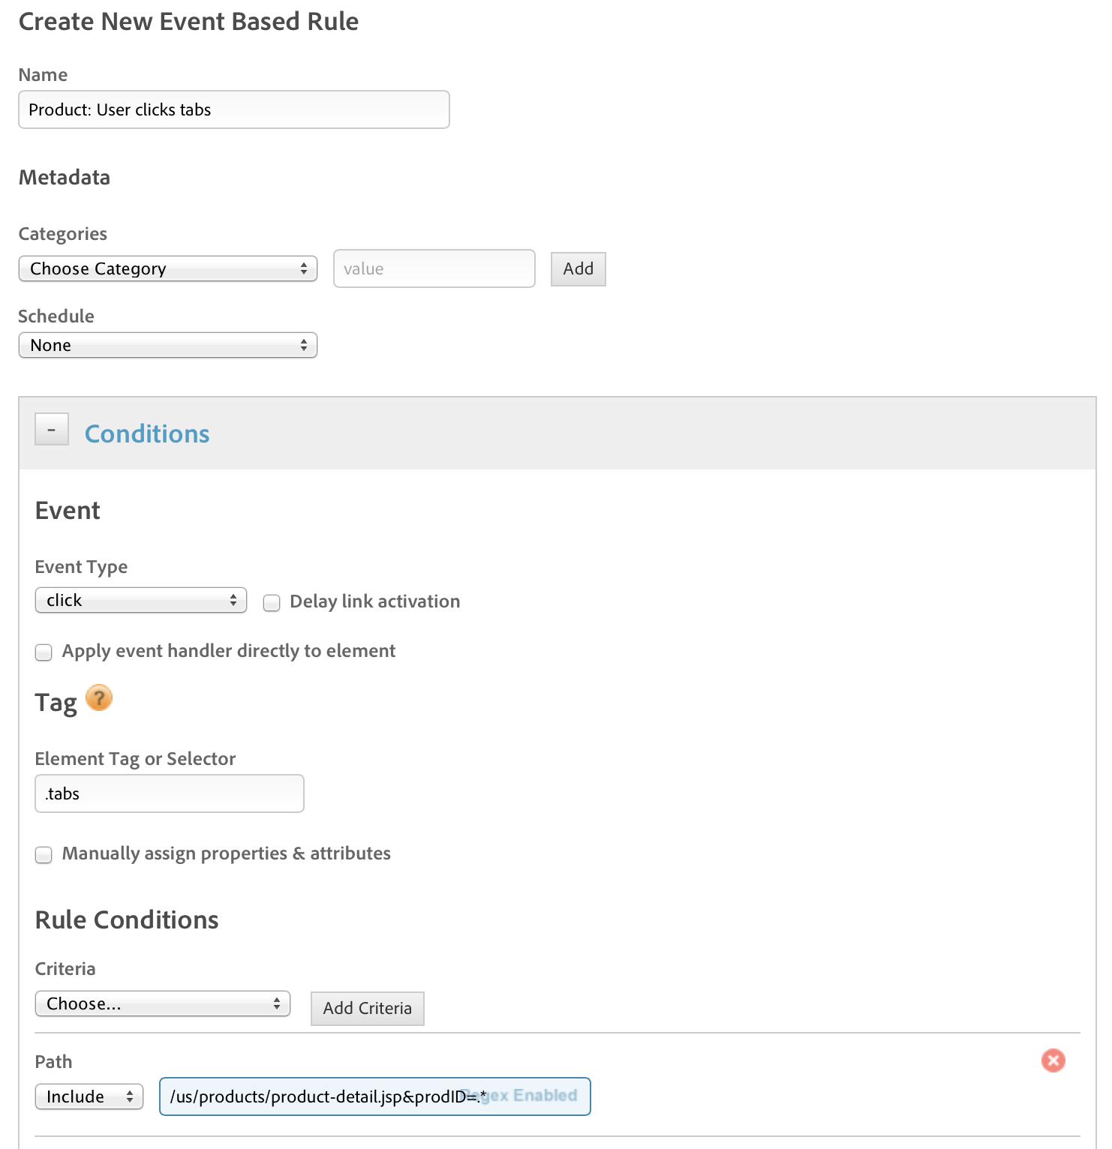

Click on event based rules and select new rule tab. The above window will appear. Categories are provided for metadata purpose.

Condition is where the event type such as click, zoom change, viewport, etc… can be selected. Tags and rules conditions are provided here.

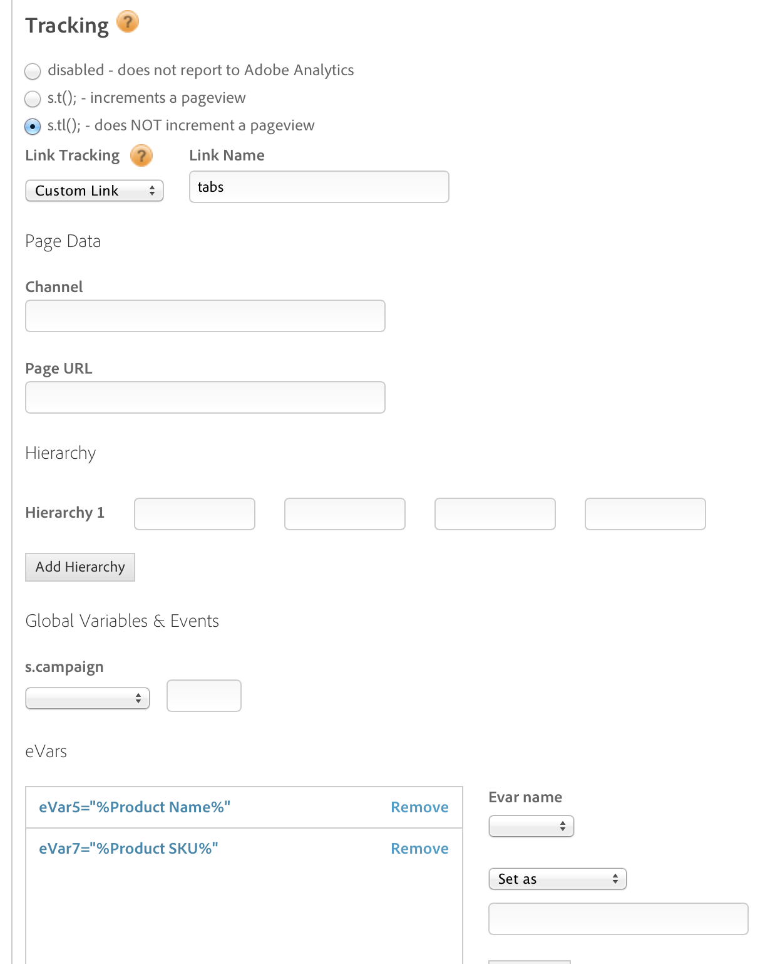

Next step is the Adobe analytics option where the mapping of the condition is done. Here we can provide the Tarcking, Global variables and events, evars and props. Evars can be duplicated in props.

If we want to include the javascript of third party tags, it is possible through Javascript/Third party tags options which is given in the event based rules window.

**Page load rules** let you target by URL, site section, or set up scenarios that are independent of the site structure.

Page load rules are created in the interface as follows:

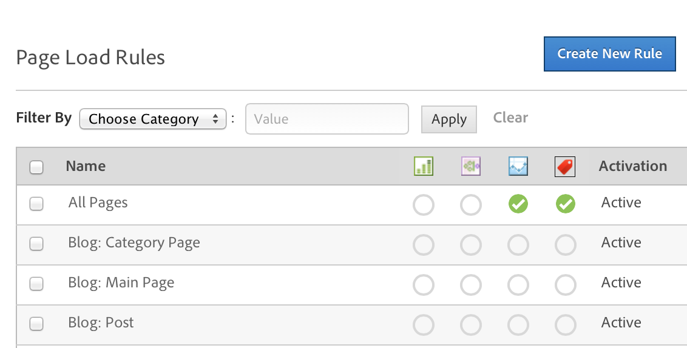

Select create new rule tab in page load rule window.

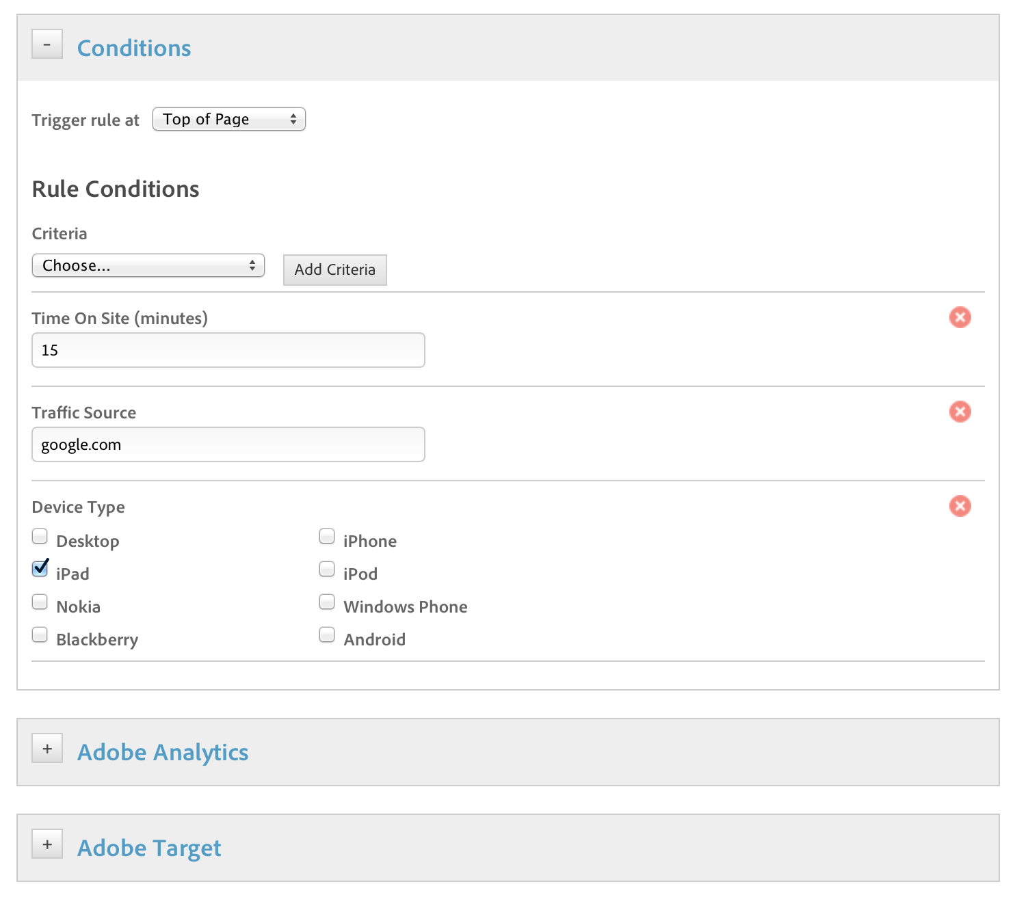

Similar to event based rule here we can give the when conditions and then is given in adobe analytics which maps the condition.

There are 2 important elements for condition

* Conditions – when to trigger
* Actions – where to trigger.

Direct call rule is designed to bypass DTM event detection and lookup systems.

They are ideal for situations where DTM get to know what exactly happens and they are also ideal when DTDM cannot detect on event in the DOM, such as with adobe flash.

1. **Testing For Rules :**

After building the rules for analytics, they must be validated whether the rules are triggered or fired or initiated during the event interaction.

The testing will be done in console.

If the rule is not fired, then the rule is again build by the programmer.